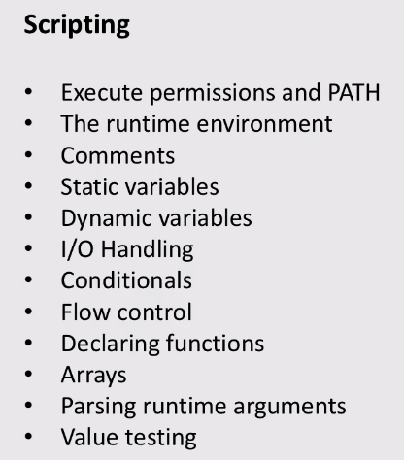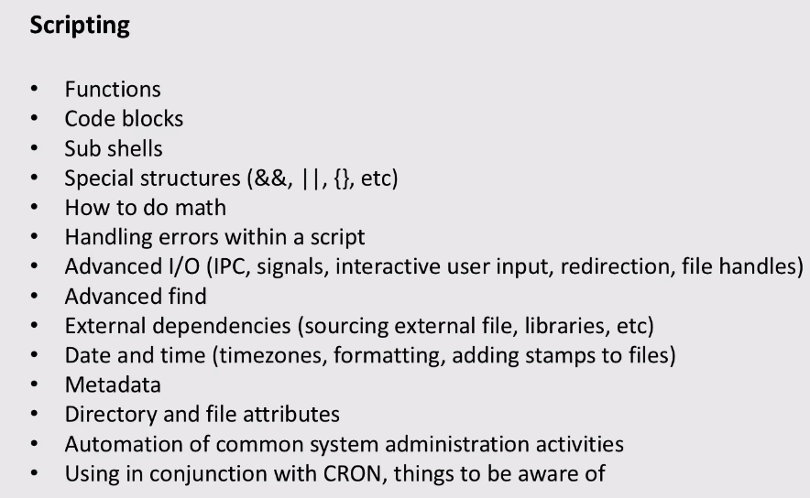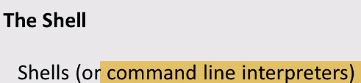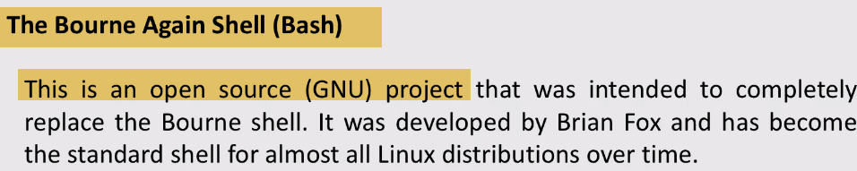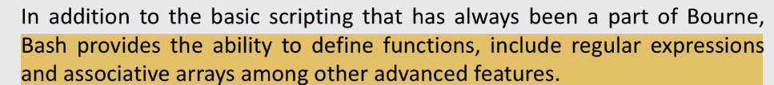

-🡪.bashrc/bash_profile

Bash_profile: Designed to **execute ONLY when you login,** before you get command prompt.

After you login, and open new window—run bashrc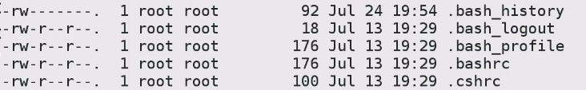

.bash_profile🡪 . Indicates local to this particular account. bash_profile varies for account

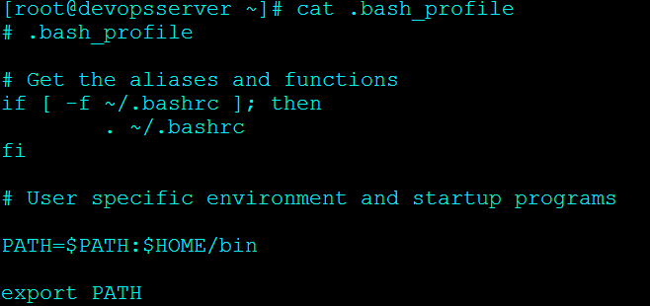

1. **If .bashrc file exists, be sure to run it.**

Whatever alias, Paths set in .bashrc .. Will also execute at login

 (OR)

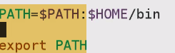-🡪 This is Good for compatibilities

Ex: 🡪list files in current dir as **well selinux settings for it**

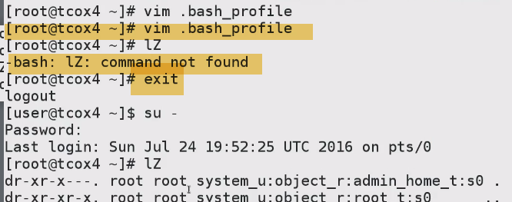

Made changes to bash_profile(added alias)..To make effect logout and login

-🡪.bashrc -🡪New terminal or tab

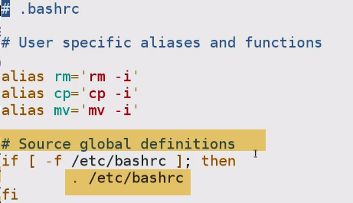We have Source Global definitions…Which is common to all(Executed for all users)------------/etc/bashrc

1. Vim ~/.bahrc🡪export Variable🡪Source bashrc or just bash 🡪env| grep –in variable



-🡪 Within current shell, start new bash instance

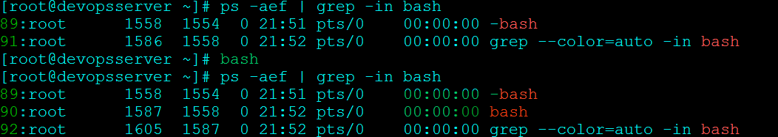

-bash is parent, bash is child…Parent killed.. stops terminal

Both are intended to call each other .bash_profile-🡪 runs .bashrc

.bashrc🡪 runs overall bash_profile(/etc/profile)…So it will make changes made overall

**----🡪.bash_history**

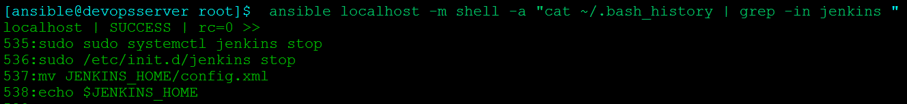

1. Not to capture history in .bash_history



**Type (space) command…>it will not be seen in bash_history**

**-🡪.bash_logout**

During logout, I want to delete some files or clean up some thing, Copy files…Write in .bash_logout

--Vim ~/.bash_logout

--Rm –rf delete.txt

--logout

--file delete.txt removed

-🡪**What makes a file as Shell Script???**

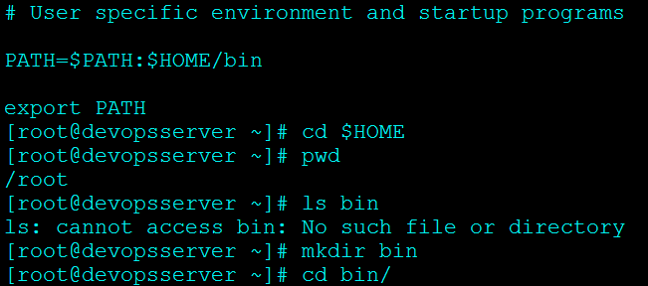

Many inexperience people thinks, it is set up unix commands in a file..

 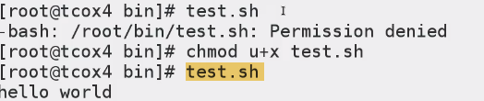

**Shell Script is typically defined by it starts a shell and executes commands within shell, and completely independent of user shell within**

So always starts with Shebang and shell to use=🡺 I’m going to write a shell script which is to be executed by bash command interpreter

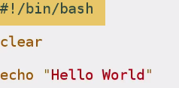

1. No need to have .sh extension for hell script

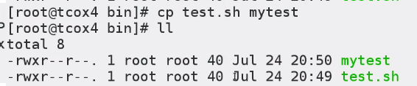



-🡪72-615-6 - Displaying Environment Variables in a Script

Simply designate by $ sign for env variables

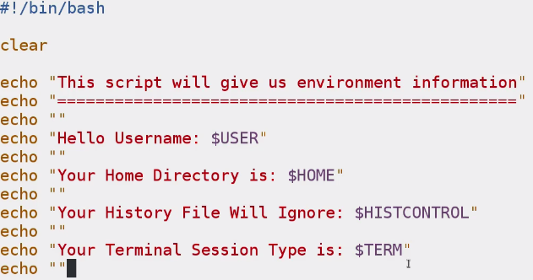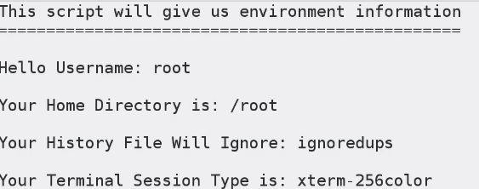

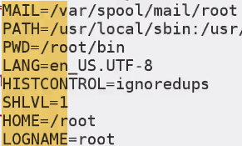

-🡪 72-615-7 - Using Variables on the Command Line

-Variable name good to be in CAPS  
- Variable Values should be enclosed in “ ”. Although not necessary.

- No Spaces before variables name

- Need to export variable name if declared.

